pvcreate /dev/sdb

pvcreate /dev/sdc

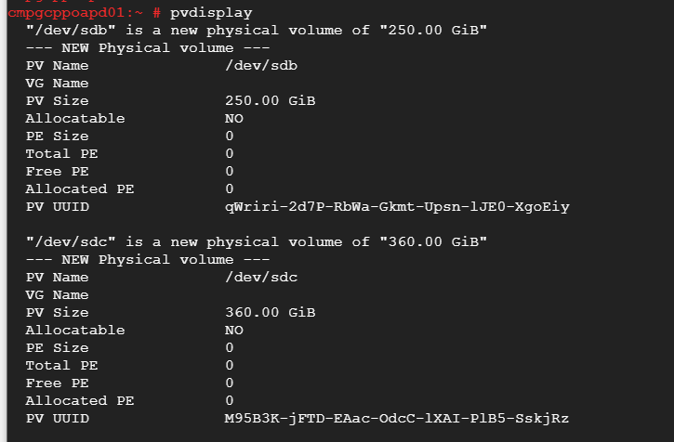

vgcreate vgstdpd /dev/sdb

vgcreate vgssdpd /dev/sdc

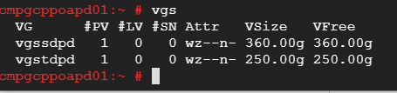

lvcreate -L 50G -n lvusrsapdxhsum vgstdpd

lvcreate -L 90G -n lvmedia vgstdpd

lvcreate -L 30G -n lvusrsapdxh vgstdpd

lvcreate -L 20G -n lvsapmnt vgstdpd

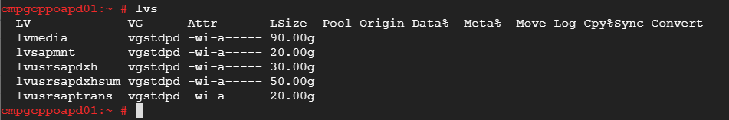

lvcreate -L 20G -n lvdxh vgssdpd

lvcreate -L 20G -n lvsaplog vgssdpd

lvcreate -L 20G -n lvbtemp vgssdpd

lvcreate -L 20G -n lvsapdiag vgssdpd

lvcreate -L 15G -n lvsybsystem vgssdpd

lvcreate -L 200G -n lvsapdata vgssdpd

lvcreate -L 20G -n lvsaptemp vgssdpd

lvcreate -L 20G -n lvswap vgssdpd

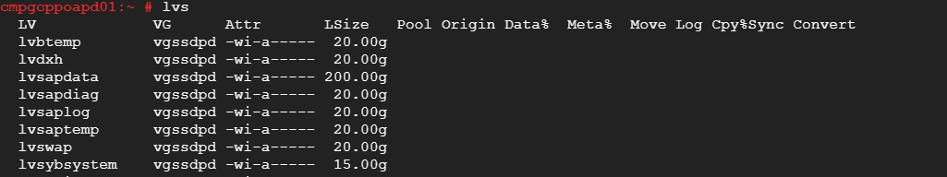

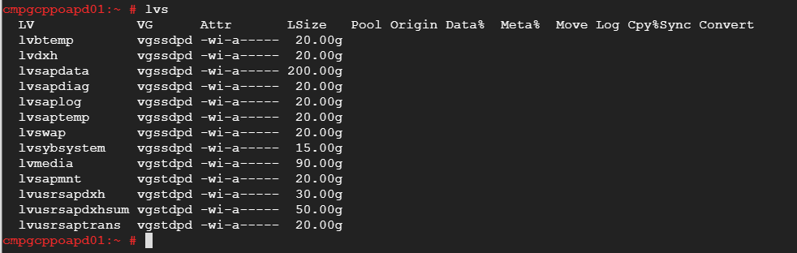

mkfs.xfs /dev/vgstdpd/lvusrsapdxhsum

mkfs.xfs /dev/vgstdpd/lvusrsapdxh

mkfs.xfs /dev/vgstdpd/lvsapmnt

mkfs.xfs /dev/vgstdpd/lvusrsaptrans

mkfs.xfs /dev/vgssdpd/lvdxh

mkfs.xfs /dev/vgssdpd/lvsaplog

mkfs.xfs /dev/vgssdpd/lvbtemp

mkfs.xfs /dev/vgssdpd/lvsapdiag

mkfs.xfs /dev/vgssdpd/lvsybsystem

mkfs.xfs /dev/vgssdpd/lvsapdata

mkfs.xfs /dev/vgssdpd/lvsaptemp

mkswap /dev/vgssdpd/lvswap

swapon /dev/vgssdpd/lvswap

mount /dev/vgstdpd/lvmedia /media

mount /dev/vgstdpd/lvusrsapdxhsum /usr/sap/DXH/SUM

mount /dev/vgstdpd/lvusrsapdxh /usr/sap/DXH

mount /dev/vgstdpd/lvsapmnt /sapmnt/DXH

mount /dev/vgstdpd/lvusrsaptrans /usr/sap/trans

mount /dev/vgssdpd/lvdxh /sybase/DXH

mount /dev/vgssdpd/lvsaplog /sybase/DXH/saplog

mount /dev/vgssdpd/lvbtemp /sybase/DXH/sybtemp

mount /dev/vgssdpd/lvsapdiag /sybase/DXH/sapdiag

mount /dev/vgssdpd/lvsybsystem /sybase/DXH/sybsystem

mount /dev/vgssdpd/lvsapdata /sybase/DXH/sapdata

mount /dev/vgssdpd/lvsaptemp /sybase/DXH/saptemp

*/dev/vg_medios/lv_medios /medios xfs defaults 0 0*

*/dev/vg_sapmnt/lv_sapmnt /sapmnt xfs defaults 0 0*

*/dev/vg_sap/lv_usrsaptrans /usr/sap/trans xfs defaults 0 0*

*/dev/vg_sap/lv_usrsap /usr/sap xfs defaults 0 0*

*/dev/vg_standar/lv_swap swap swap defaults 0 0*

/dev/vgssdpd/lvsaplog   /sybase/QXH/saplog  xfs     defaults    0 0

/dev/vgssdpd/lvbtemp    /sybase/QXH/sybtemp     xfs     defaults    0 0

/dev/vgssdpd/lvsapdiag  /sybase/QXH/sapdiag     xfs     defaults    0 0

/dev/vgssdpd/lvsybsystem    /sybase/QXH/sybsystem   xfs     defaults    0 0

/dev/vgssdpd/lvsapdata  /sybase/QXH/sapdata     xfs     defaults    0 0

/dev/vgssdpd/lvsaptemp  /sybase/QXH/saptemp     xfs     defaults    0 0

/dev/vgstdpd/lvusrsapqxhsum  /usr/sap/QXH/SUM   xfs     defaults    0 0

/dev/vgstdpd/lvmedia    /media  xfs     defaults    0 0

/dev/vgstdpd/lvusrsapqxh    /usr/sap/QXH    xfs     defaults    0 0

/dev/vgstdpd/lvusrsaptrans  /usr/sap/trans  xfs     defaults    0 0

/dev/vgstdpd/lvsapmnt   /sapmnt/QXH     xfs     defaults    0 0

/dev/vgssdpd/lvqxh  /sybase/QXH     xfs     defaults    0 0

/dev/vgssdpd/lvswap     swap    swap defaults   0 0

/dev/vgstdpd/lvmedia /media xfs defaults 0 0

/dev/vgstdpd/lvusrsapdxhsum /usr/sap/DXH/SUM xfs defaults 0 0

/dev/vgstdpd/lvusrsapdxh /usr/sap/DXH xfs defaults 0 0

/dev/vgstdpd/lvsapmnt /sapmnt/DXH xfs defaults 0 0

/dev/vgstdpd/lvusrsaptrans /usr/sap/trans xfs defaults 0 0

/dev/vgssdpd/lvdxh /sybase/DXH xfs defaults 0 0

/dev/vgssdpd/lvsaplog /sybase/DXH/saplog xfs defaults 0 0

/dev/vgssdpd/lvbtemp /sybase/DXH/sybtemp xfs defaults 0 0

/dev/vgssdpd/lvsapdiag /sybase/DXH/sapdiag xfs defaults 0 0

/dev/vgssdpd/lvsybsystem /sybase/DXH/sybsystem xfs defaults 0 0

/dev/vgssdpd/lvsapdata /sybase/DXH/sapdata xfs defaults 0 0

/dev/vgssdpd/lvsaptemp /sybase/DXH/saptemp xfs defaults 0 0

/dev/vgssdpd/lvswap swap swap defaults 0 0